Fossilization Process
The process of fossilization varies according to tissue type and external conditions.

Permineralization
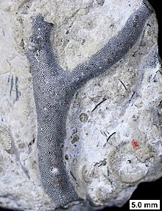
Permineralized bryozoan from the Devonian of Wisconsin.
Permineralization is a process of fossilization that occurs when an organism is buried. The empty spaces within an organism (spaces filled with liquid or gas during life) become filled with mineral-rich groundwater. Minerals precipitate from the groundwater, occupying the empty spaces. This process can occur in very small spaces, such as within the cell wall of a plant cell. Small scale permineralization can produce very detailed fossils. For permineralization to occur, the organism must become covered by sediment soon after death, otherwise decay commences. The degree to which the remains are decayed when covered determines the later details of the fossil. Some fossils consist only of skeletal remains or teeth; other fossils contain traces of skin, feathers or even soft tissues. This is a form of diagenesis.

Casts and molds
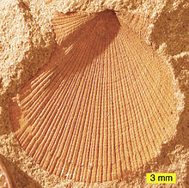
External mold of a bivalve from the Logan Formation, Lower Carboniferous, Ohio
In some cases, the original remains of the organism completely dissolve or are otherwise destroyed. The remaining organism-shaped hole in the rock is called an external mold. If this hole is later filled with other minerals, it is a cast. An endocast, or internal mold, is formed when sediments or minerals fill the internal cavity of an organism, such as the inside of a bivalve or snail or the hollow of a skull.

Authigenic mineralization
This is a special form of cast and mold formation. If the chemistry is right, the organism (or fragment of organism) can act as a nucleus for the precipitation of minerals such as siderite, resulting in a nodule forming around it. If this happens rapidly before significant decay to the organic tissue, very fine three-dimensional morphological detail can be preserved. Nodules from the Carboniferous Mazon Creek fossil beds of Illinois, USA, are among the best documented examples of such mineralization.

Replacement and recrystallization
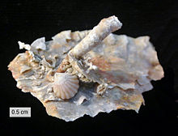
Silicified (replaced with silica) fossils from the Road Canyon Formation (Middle Permian of Texas)
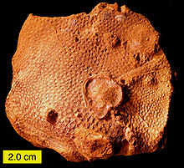
Recrystallized scleractinian coral (aragonite to calcite) from the Jurassic of southern Israel
Replacement occurs when the shell, bone or other tissue is replaced with another mineral. In some cases mineral replacement of the original shell occurs so gradually and at such fine scales that microstructural features are preserved despite the total loss of original material. A shell is said to be recrystallized when the original skeletal compounds are still present but in a different crystal form, as from aragonite to calcite.

Adpression (compression-impression)
Compression fossils, such as those of fossil ferns, are the result of chemical reduction of the complex organic molecules composing the organism's tissues. In this case the fossil consists of original material, albeit in a geochemically altered state. This chemical change is an expression of diagenesis. Often what remains is a carbonaceous film known as a phytoleim, in which case the fossil is known as a compression. Often, however, the phytoleim is lost and all that remains is an impression of the organism in the rock—an impression fossil. In many cases, however, compressions and impressions occur together. For instance, when the rock is broken open, the phytoleim will often be attached to one part (compression), whereas the counterpart will just be an impression. For this reason, one term covers the two modes of preservation: adpression.^{[9]}

Soft tissue, cell and molecular preservation
Because of their antiquity, an unexpected exception to the alteration of an organism's tissues by chemical reduction of the complex organic molecules during fossilization has been the discovery of soft tissue in dinosaur fossils, including blood vessels, and the isolation of proteins and evidence for DNA fragments.^{[10][11][12][13]} In 2014, Mary Schweitzer and her colleagues reported the presence of iron particles (goethite-aFeO(OH)) associated with soft tissues recovered from dinosaur fossils. Based on various experiments that studied the interaction of iron in haemoglobin with blood vessel tissue they proposed that solution hypoxia coupled with iron chelation enhances the stability and preservation of soft tissue and provides the basis for an explanation for the unforeseen preservation of fossil soft tissues.^{[14]} However, a slightly older study based on eight taxa ranging in time from the Devonian to the Jurassic found that reasonably well-preserved fibrils that probably represent collagen were preserved in all these fossils and that the quality of preservation depended mostly on the arrangement of the collagen fibers, with tight packing favoring good preservation.^{[15]} There seemed to be no correlation between geological age and quality of preservation, within that timeframe.

Carbonization and Coalification
Fossils that are carbonized or coalified consist of the organic remains which have been reduced primarily to the chemical element carbon. Carbonized fossils consist of a thin film which forms a silhouette of the original organism, and the original organic remains were typically soft tissues. Coalified fossils consist primarily of coal, and the original organic remains were typically woody in composition.
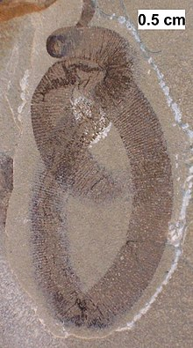
Carbonized fossil of a possible leech from the Silurian Waukesha Biota of Wisconsin.
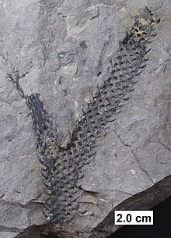
Partially coalified axis (branch) of a lycopod from the Devonian of Wisconsin.

Bioimmuration
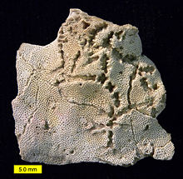
The star-shaped holes (Catellocaula vallata) in this Upper Ordovician bryozoan represent a soft-bodied organism preserved by bioimmuration in the bryozoan skeleton.^{[16]}
Bioimmuration occurs when a skeletal organism overgrows or otherwise subsumes another organism, preserving the latter, or an impression of it, within the skeleton.^{[17]} Usually it is a sessile skeletal organism, such as a bryozoan or an oyster, which grows along a substrate, covering other sessile sclerobionts. Sometimes the bioimmured organism is soft-bodied and is then preserved in negative relief as a kind of external mold. There are also cases where an organism settles on top of a living skeletal organism that grows upwards, preserving the settler in its skeleton. Bioimmuration is known in the fossil record from the Ordovician^{[18]} to the Recent.^{[17]}

